國立臺北科技大學一百學年第一學期
能源與冷凍空調工程研究所
博士班資格考試
熱力學試題
填學生證號碼 There are【4】 pages. This is page 1

Attentions：
1. There are 【6】 problems on this exam, of which you are instructed to work only
【5】. If you work all 【6】 problems, only the first 【5】 will be graded.
Each problem gets 【20】 points.
2. Please answer the problems by order. Don’t need to copy the problems on the answer sheet. Write all your answers on the answer sheet.
3. Do not write your name on the answer sheet.
4. ( )open book ( x )close book

1. A closed system with 1 kg of water and 1kg of steam balanced at 700kPa,
- Find the initial temperature and quality.
- If heated at constant pressure until 350℃, determine the changes in system volume.

2.A piston steam engine begins with 1.0MPa and 500℃ undergoes polytropic process with n=1.35 expanding to 200kPa. Determine the work and heat exchange.

3.Ideal gas in a closed system undergoes a constant temperature process, show that all the heat input converted to work. Does it violate the second law.

4.An inventor claims that he invent a heat engine that using a 400 K heat source supply 800 kJ engine can output 250 kJ of work with the heat sink at 300K. Discuss the feasibility.

5.A piece of 1.5 kg copper with initial temperature at 700K and cooled in the atmosphere until 300K. Calculate the entropy change for the copper and the atmosphere and also the total entropy change. The specific heat of copper is assumed to be 0.39 kJ/kg-K.

There are【4】 pages. This is page 2.

6. Air at 0.1MPa and 300K undergoes reversible compression to 1.0MPa. Determine the work input and the exit temperature.

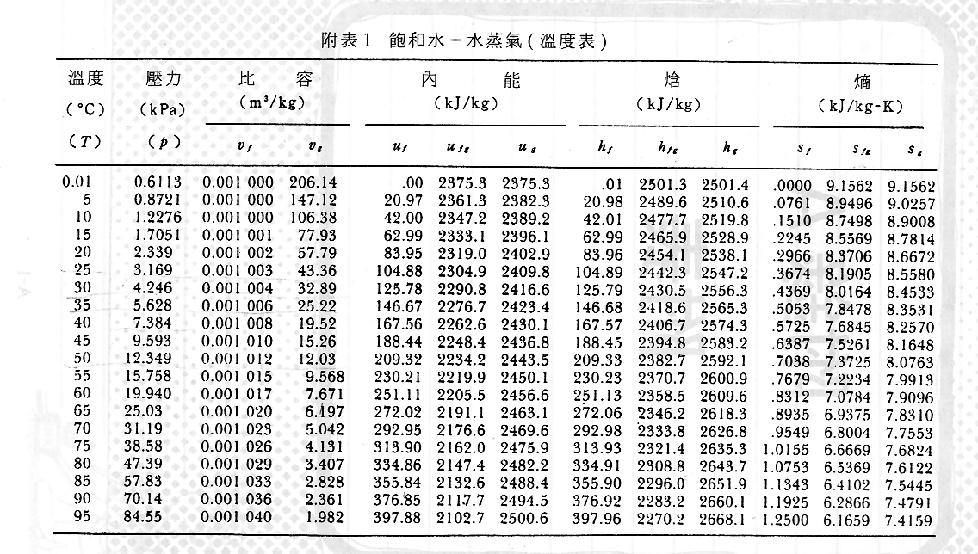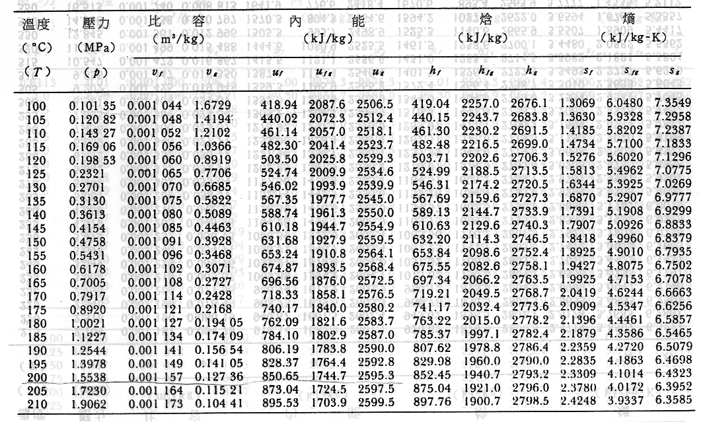

There are【4】 pages. This is page 3.

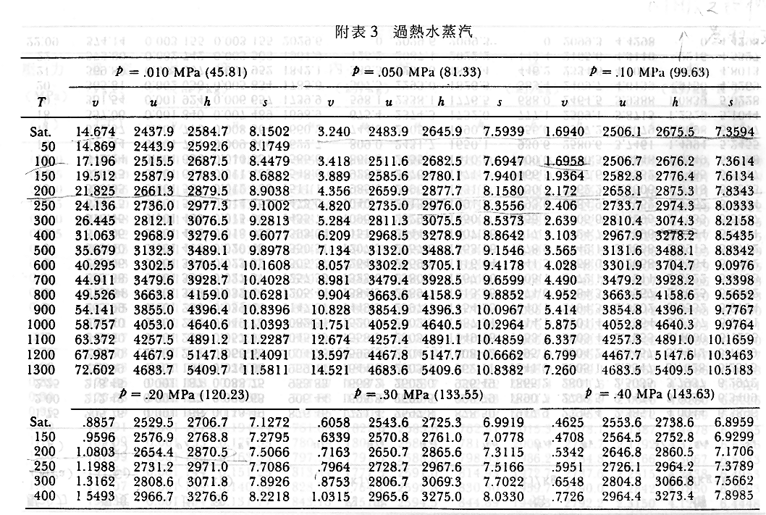
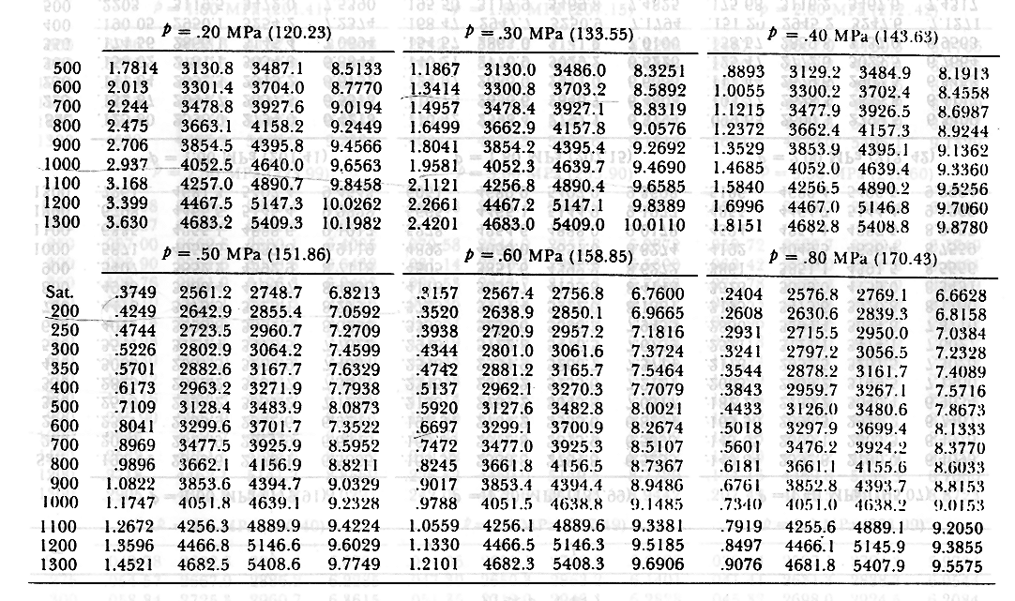

There are【4】 pages. This is page 4.

