能源工程概論 Example 3

- A cyclic machine, shown in Fig. 1, receives 325 kJ from a 1000 K energy reservoir. It rejects 125 kJ to a 400 K energy reservoir, and the cycle produces 200 kJ of work as output. Is this cycle reversible, irreversible, or impossible?

Fig. 1

- A heat pump is used to maintain a house at a constant temperature of 23 ⁰C. The house is losing heat to the outside air through the walls and the windows at a rate of 60,000 kJ/h while the energy generated within the house from people, lights, and appliances amounts to 4000 kJ/h. For a COP of 2.5, determine the required power input to the heat pump.

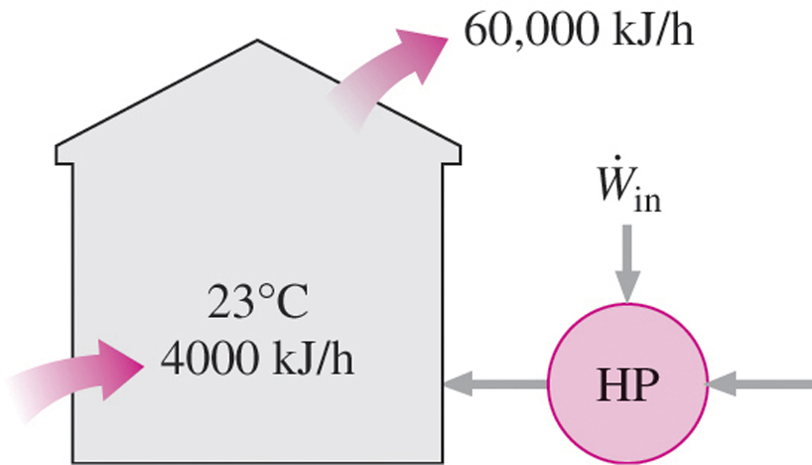

Fig. 2

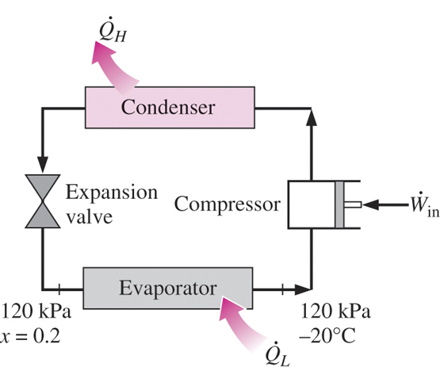
Fig. 3
- Refrigerant-134a enters the evaporator coils placed at the back of the freezer section of a household refrigerator at 120 kPa with a quality of 20% and leaves at 120 kPa and –20 ⁰C. If the compressor consumes 450 W of power and the COP of the refrigerator is 1.2, determine (a) the mass flow rate of the refrigerant and (b) the rate of heat rejected to the kitchen air.

- A refrigerator is to remove heat from the cooled space at a rate of 300 kJ/min to maintain its temperature at –8 ⁰C. If the air surrounding the refrigerator is 25 ⁰C, determine the minimum power input required for this refrigerator.
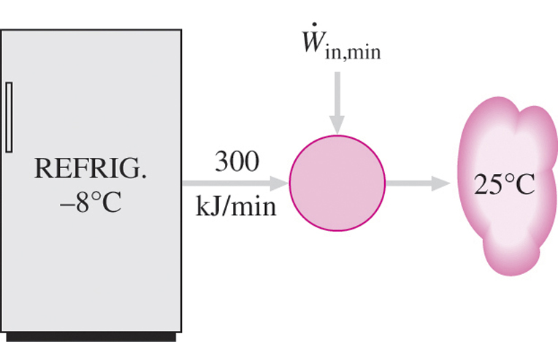

Fig. 4

- An air-conditioner with refrigerant-134a as the working fluid is used to keep a room at 26 ⁰C by rejecting the waste heat to the outdoor air at 34 ⁰C. The room gains heat through the walls and the windows at a rate of 250 kJ/min while the heat generated by the computer , TV, and lights amounts to 900 W. The refrigerant enters the compressor at 500 kPa at a saturated vapor at a rate of 100 L/min and leaves at 1200 kPa and 50 ⁰C. Determine (a) the actual COP, (b) the maximum COP, and (c) the minimum volume flow rate of the refrigerant at the compressor inlet for the same compressor inlet and exit conditions.

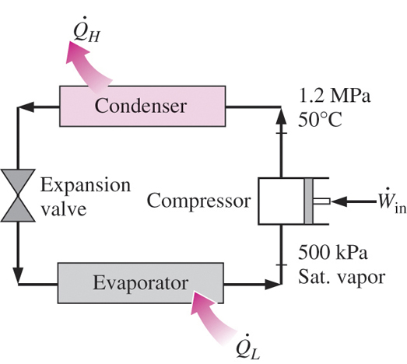
Fig. 5

- An automobile engine consumes fuel at a rate of 28 L/h and delivers 60 kW of power to the wheels. If the fuel has heating value of 44,000 kJ/kg and a density of 0.8 g/cm³, determine the efficiency of this engine.

7. An Ocean Thermal Energy Conversion (OTEC) power plant built in Hawaii in 1987 was designed to operate between the temperature limits of 30 ⁰C at the ocean surface and 5 ⁰C at a depth of 650 m. About 50 m³/min of cold seawater was to be pumped from deep ocean through a 1-m-diameter pipe to serve as the cooling medium or heat sink. If the cooling seawater experiences a temperature rise of 4 ⁰C and the thermal efficiency is 2.5 percent, determine the amount of power generated. Take the density of seawater to be 1025 kg/m³.

